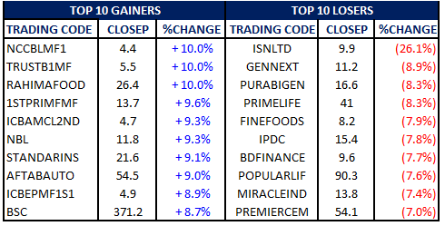
AT CAPITAL DAILY MARKET UPDATE – 12th May, 2015

^{April} 2012
Overview
The DSEX closed at 4326.6 points, up by 22.6 points. The total transaction was worth BDT 5.5bn.
Price of 103 Issues appreciated whereas 185 issues declined and 18 others remained unchanged.

Index Movements:
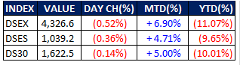

** Top Loser List not adjusted for Right/stock dividend post record
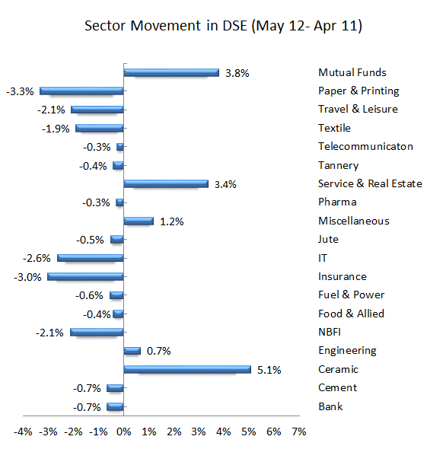

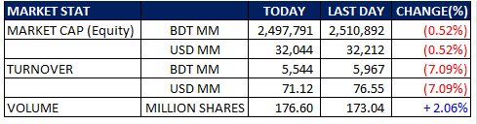

Market Commentary:
Market experienced mild correction after 5 consecutive bullish sessions due to actual and perceived profit taking by short term investors. Market started in positive trend but later experienced some correction and at the end DSEX closed at 4326.6 points with lower investors’ activity.
Turnover decreased and stood at BDT 5.5 bn which is 7.1% higher than yesterday.
Among the prominent sectors Ceramics, Mutual Funds, Service & Real Estate, Miscellaneous, Engineering, Pharma, Telecommunication, Tannery, Food & Allied and Jute outperformed the market while the rests underperformed. Ceramic sectors posted the sharp gain of 5.1% dominated by RAKCERAMIC.
United Power Generation and Distribution Company (UPGDCL) was the daily turnover leader contributing 6.9% to the total turnover.

Last 1 Month DSEX
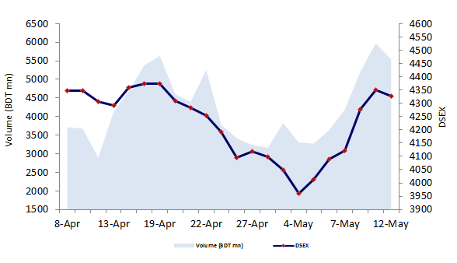

News:

SEXUAL HARASSMENT ON POHELA BOISHAK; 21 injured as police attack protesters
At least 21 protestors, including two women, were injured after police charge baton and used water cannon on a peaceful march towards Dhaka Metropolitan Police headquarters demanding the arrest of suspects involved in sexual harassment of women gathered at the Dhaka University campus during Pahela Baishakh celebrations. voice said that her last wish was to see her children and grandchildren get an identity for which all in her generation suffered.
Her 54-year son Nazrul Islam said, ‘What the enclave people want is nationality and access to government facilities.’ he added that all of them were happy over the latest development in the process for exchanging 162 enclaves between Bangladesh and India under the land boundary agreement signed back in 1974.
http://newagebd.net/118818/21-injured-as-police-attack-protesters/#sthash.tPpm2oiT.dpuf

Investment in zero-coupon bonds
BB seeks tax exemption for banks, FIs, insurance cos
The central bank has advised the tax authorities to make the revenue earned from investment in the zero-coupon bonds by banks, financial institutions (FIs) and insurance companies tax-free.
The BB governor Dr Atiur Rahman made the suggestion in a recently-sent Demy Official (DO) letter to the National Board of Revenue (NBR) Chairman Nojibur Rahman. He requested the NBR chief to consider reintroduction of the tax exemption provision in the income tax ordinance. The government in 2007 had scrapped the provision that allowed the banks, FIs and insurers to enjoy the tax exemption facility on account of their earning from investments in the zero-coupon bonds.
http://www.thefinancialexpress-bd.com/2015/05/11/92225

BD ship-breaking faces opposition from abroad
CHITTAGONG, May 10: Some international quarters have taken a stance against Bangladesh's ship-breaking industry citing concerns on the safety and environment fronts.
The Norwegian Ship Owners' Association (NSA) at a recent convention in Singapore advised its members not to allow recycling of their ships in Bangladesh, unless it is clearly monitored and undertaken as part of projects aimed at improving standards as per the Hong Kong International Convention for 'Safe and Environmentally Sound' recycling of ships. According to sources, Tor Christian Sletner, NSA's head of environment, told delegates at the Trade Winds Ship Recycling Forum in Singapore in mid-March that the NSA decided not to export their ships for recycling in Bangladesh, as several attempts to raise the ship recycling standards in the country failed.
http://www.thefinancialexpress-bd.com/2015/05/11/92227

