Overview:
The DSEX closed at 5,844.7 points, up by 9.9 points. Total turnover was worth BDT 12.63 bn. Prices of 155 issues were increased whereas that of 142 issues were declined, and the price of the rests were remained unchanged.
AT CAPITAL DAILY MARKET UPDATE – July 16, 2017
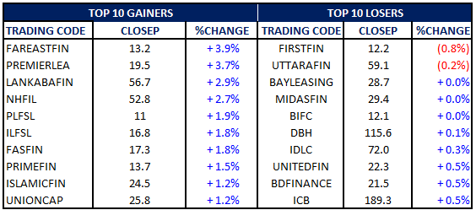

Index Movements:
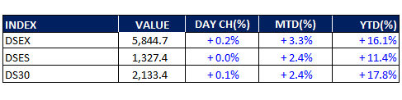

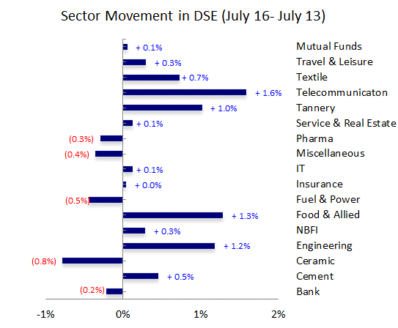

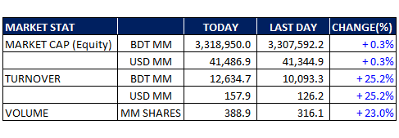

Market commentary:
Upward continued for another session. DSEX, the broad index, was skyrocketed as soon as the opening was rang, hitting the day’s high of ~5880.0. Since then, DSEX shed steadily till the end of the session, paring most of the initial gain. Market closed the session at 5,844.7, up by 9.9 points – the high of the DSEX was created.

Turnover increased by 25.2% to BDT 12.63 bn. Textile sector dominated the turnover chart - the sector accounted for 19.0% of total turnover, followed by Engineering (14.7%) and, Fuel & Power sector (11.6%).

Among prominent sectors, Engineering, Cement, Food and allied, Telecommunication, Textiles and NBFI sectors outperformed the market whereas Bank, Fuel & Power, and Pharma sectors underperformed the market today.

IFAD Autos topped the turnover chart today with the turnover of BDT 734mn - the stock gained 3.5%.

Last 1 Month DSEX
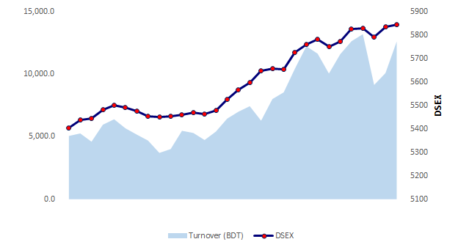

News:
Banking Companies Act to be amended to fund power projects
The government may amend the banking law to facilitate the country's power sector to get loans beyond the single borrower exposure limit. The move comes after the power division last month requested banks to channel Tk 20,000 crore into the power sector over the next six months. At present, banks can provide loans of up to 25 percent of their capital to a single borrower. For some banks it would not be possible to lend at a scale needed by the power sector companies without exceeding the limit. For instance, a prominent business group has recently sought a large sum for its power project from a state-owned bank but was turned away due to the single borrower exposure provision. This prompted the chairman of the group to request the Bangladesh Bank to relax the provision. Subsequently, a committee was formed on July 4 to go through the Bank Company Act 1991 to check if there is any provision that bars banks from providing large loans to the power sector. If yes, the committee has to recommend the necessary amendments. The single borrower exposure limit is a global practice to enable banks to effectively manage their credit risks, said Salehuddin Ahmed, a former governor of the BB. He said the amendment of the provision to facilitate a certain sector will put the banks at risk and harm the financial stability. Moreover, such amendment will reduce the bank's ability to comply with Basel-III capital requirement, Ahmed added. The move to amend the law is to facilitate a certain business group, said a senior executive of a private bank. “It will open up opportunity for the group to take money from the government bank,” he added. The Banking Companies Act 1991 was last amended in 2013 to extend the tenure of shareholding directors and double the number of directors in a bank's board from a single family.

http://www.thedailystar.net/business/banking-companies-act-be-amended-fund-power-projects-1433863

Satellite's ground stations testing begins in Sep
Bangabandhu-1 satellite's ground stations will be ready for testing from September as 88 percent work of the project has already been completed, said State Minister for Telecom Tarana Halim yesterday. “We hope to launch the Bangabandhu-1 satellite commercially by April next year, which was earlier scheduled for next June,” she told reporters while visiting one of the stations in Gazipur to oversee the progress made. The other is in Rangamati's Bethbunia. She said the ground stations would start holding test runs from October. Construction of Bangladesh's first satellite is expected to be completed in November. The launch depends on different factors such as the weather and schedule of the launch from the US. The government had earlier planned to hold the launch in December from Florida. French firm Thales Alenia Space is manufacturing the satellite for $248 million (Tk 1,959 crore) under an agreement signed with Bangladesh Telecommunication Regulatory Commission in November 2015. The most sophisticated technological project in Bangladesh is costing around Tk 2,967.95 crore. It might come down by a few hundred crore taka, said Tarana in reply to a question. Tarana said local and foreign companies were being contacted for the sale of half of the satellite's capacity on connectivity. There have been positive responses from Indonesia and some local companies, said project officials. The cabinet already passed a proposal for forming a public limited company to look after the satellite's businesses for the next three years as a local partner of Thales Alenia Space. The satellite will bring down television broadcasting costs to just one tenth of what is incurred now, said the officials. It will take seven years to recoup the investment while the project will put Bangladesh on track to become a developed country, said Tarana.

http://www.thedailystar.net/business/satellites-ground-stations-testing-begins-sep-1433884

